FACE DETECTION SYSTEM
ABSTRACT

- The face is one of the easiest ways to distinguish the individual identity of each other. Face recognition is a personal identification system that uses personal characteristics of a person to identify the person's identity.
- There are two kinds of methods that are currently popular in developed face recognition pattern namely, Eigenface method and Fisherface method.
- Facial image recognition Eigenface method is based on the reduction of face-dimensional space using Principal Component Analysis (PCA) for facial features. The main purpose of the use of PCA on face recognition using Eigen faces was formed (face space) by finding the eigenvector corresponding to the largest eigenvalue of the face image.
- The software requirements for this project is matlab software. Keywords: face detection, Eigen face, PCA, matlab
- Extension: There are vast number of applications from this face detection project, this project can be extended that the various parts in the face can be detect which are in various directions and shapes.

INTRODUCTION

Face recognition is the task of identifying an already detected object as a known or
unknown face.
Face detection involves separating image windows into two classes; one containing faces (tarning the background (clutter). It is difficult because although commonalities exist between faces, they can vary considerably in terms of age, skin colour and facial expression.
The problem is further complicated by differing lighting conditions, image qualities and geometries, as well as the possibility of partial occlusion and disguise.
An ideal face detector would therefore be able to detect the presence of any face under any set of lighting conditions, upon any background.
The face detection task can be broken down into two steps.
The first step is a classification task that takes some arbitrary image as input and outputs a binary value of yes or no, indicating whether
there are any faces present in the image.
The second step is the face localization task that aims to take an image as input and output the location of any face or faces within that image as some bounding box with (x, y, width, height).

The face detection system can be divided into the following steps:-

1. Pre-Processing: To reduce the variability in the faces, the images are processed before they are fed into the network. All positive examples that is the face images are obtained by cropping images with frontal faces to include only the front view. All the cropped images are then corrected for lighting through standard algorithms.

2. Classification: Neural networks are implemented to classify the images as faces or nonfaces by training on these examples. We use both our implementation of the neural network and the Matlab neural network toolbox for this task. Different network configurations are experimented with to optimize the results.

3. Localization: The trained neural network is then used to search for faces in an image and if present localize them in a bounding box. Various Feature of Face on which the work has done on:- Position Scale Orientation Illumination.

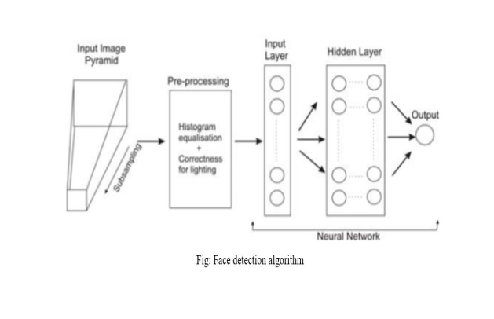

LITERATURE SURVEY

Face detection is a computer technology that determines the location and size of human face in arbitrary (digital) image. The facial features are detected and any other objects like trees, buildings and bodies etc are ignored from the digital image.
It can be regarded as a specific‘ case of object-class detection, where the task is finding the location and sizes of all objects in an image that belong to a given class. Face detection, can be regarded as a more general‘ case of face localization.
In face localization, the task is to find the locations and sizes of a known number of
faces (usually one). Basically there are two types of approaches to detect facial part in the given image i.e. feature base and image base approach.
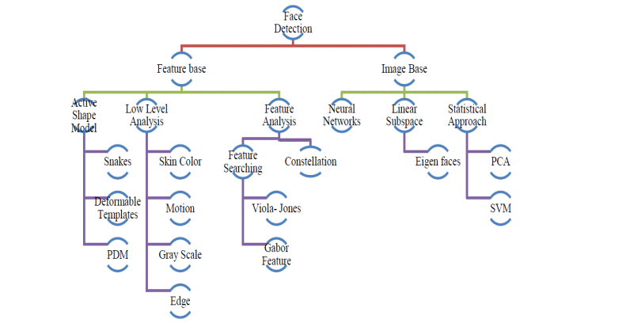
Feature base approach tries to extract features of the image and match it against the knowledge of the face features. While image base approach tries to get best match between training and testing images.

Majorly three different face detection algorithms are available based on RGB, YCbCr, and HIS color space models.In the implementation of the algorithms there are three main steps viz.
(1) Classify the skin region in the color space,
(2) Apply threshold to mask the skin region and
(3) Draw bounding box to extract the face image.

MOTION BASE:
When useof video sequence is available, motion informationcan be used to locate moving objects. Movingsilhouettes like face and body parts can be extractedby simply thresholding accumulated framedifferences . Besides face regions, facial featurescan be located by frame differences .

Edge Base:
Face detection based on edges was introduced by Sakai et al. This workwas based on
analysing line drawings of the faces from photographs, aiming to locate facialfeatures. Than later Craw et al. proposed a hierarchical framework based on Sakai et al.‘swork to trace a human head outline. Then after remarkable works were carried out by many researchers in this specific area. Method suggested by Anila and Devarajan was very simple and fast. They proposed frame work which consist three stepsi.e. initially the images are enhanced by applying median filterfor noise
removal and histogram equalization for contrast adjustment. In the second step the edge imageis constructed from the enhanced image by applying sobel operator. Then a novel edge trackingalgorithm is applied to extract the sub windows from the enhanced image based on edges. Further they used Back propagation Neural Network (BPN) algorithm to classify the sub-window as either face or non-face.

FEATURE ANALYSIS

These algorithms aimto find structural features that exist even when thepose, viewpoint, or lighting conditions vary, andthen use these to locate faces. These methods aredesigned mainly for face localization

FUNDAMENTAL STEPS IN IMAGE PROCESSING

Fundamental steps in image processing are

1. Image acquisition: to acquire a digital image
2. Image pre-processing: to improve the image in ways that increases the chances for success
of the other processes.
3. Image segmentation: to partitions an input image into its constituent parts of objects.
4. Image segmentation: to convert the input data to a from suitable for computer processing.
5. Image description: to extract the features that result in some quantitative information of
interest of features that are basic for differentiating one class of objects from another.
6. Image recognition: to assign a label to an object based on the information provided by its description.
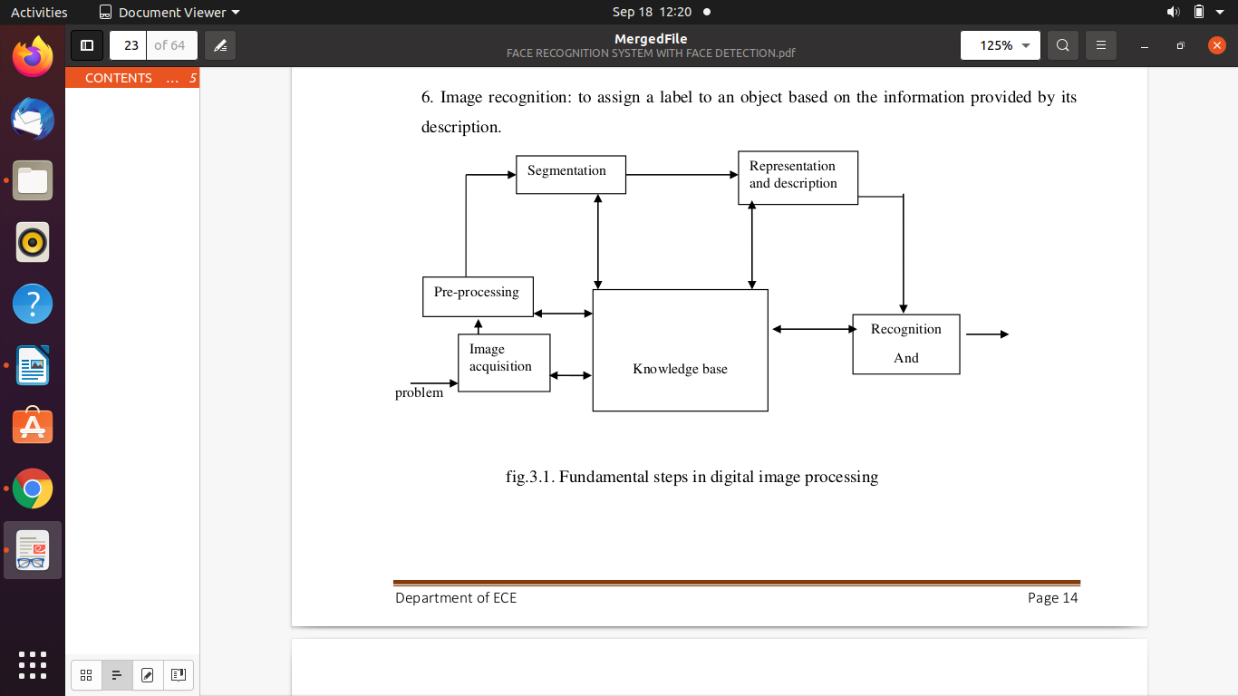

The basic operations performed in a digital image processing system include

1. Acquisition
2. Storage
3. Processing
4. Communication
5. Display

FACE DETECTION

The problem of face recognition is all about face detection. This is a fact that seems quite bizarre to new researchers in this area. However, before face recognition is possible, one must be able to reliably find a face and its landmarks. This is essentially a segmentation problem and in practical systems, most of the effort goes into solving this task. In fact the actual recognition based
on features extracted from these facial landmarks is only a minor last step.

There are two types of face detection problems:

1) Face detection in images and
2) Real-time face detection

FACE DETECTION IN IMAGES

Most face detection systems use an example based learning approach to decide whether or not a face is present in the window at that given instant (Sung and Poggio,1994 and Sung,1995). A neural network or some other classifier is trained using supervised learning with 'face' and 'non- face' examples, thereby enabling it to classify an image (window in face detection system) as a
'face' or 'non-face'.. Unfortunately, while it is relatively easy to find face examples, how would one find a representative sample of images which represent non-faces (Rowley et al., 1996)? Therefore, face detection systems using example based learning need thousands of 'face' and 'non-face' images for effective training. Rowley, Baluja, and Kanade (Rowley et al.,1996) used 1025 face images and 8000 non-face images (generated from 146,212,178 sub images) for their training set!
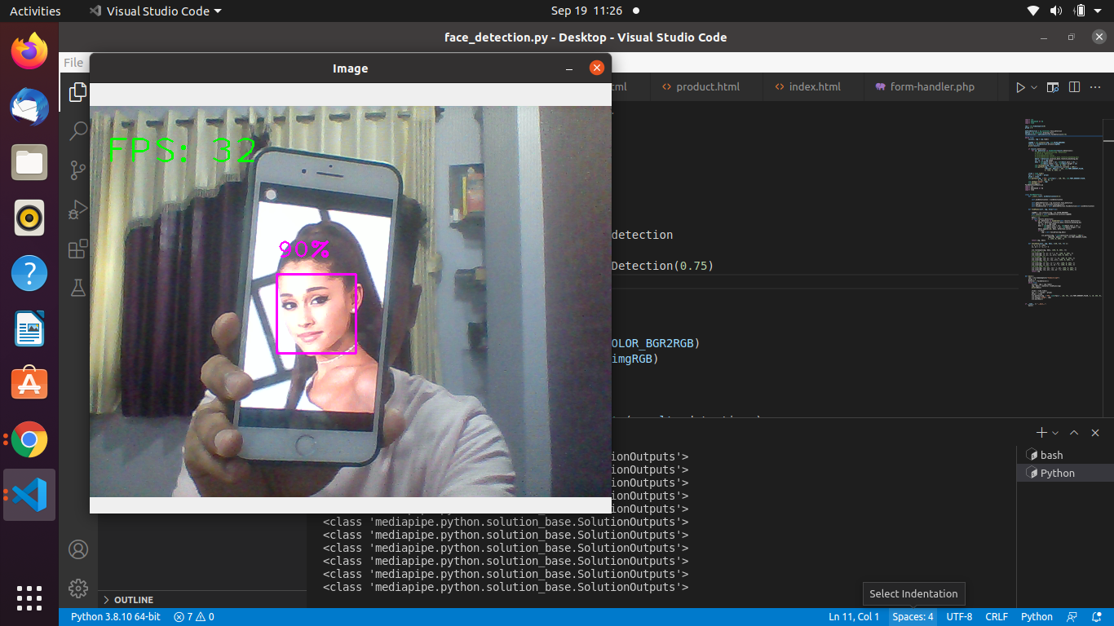

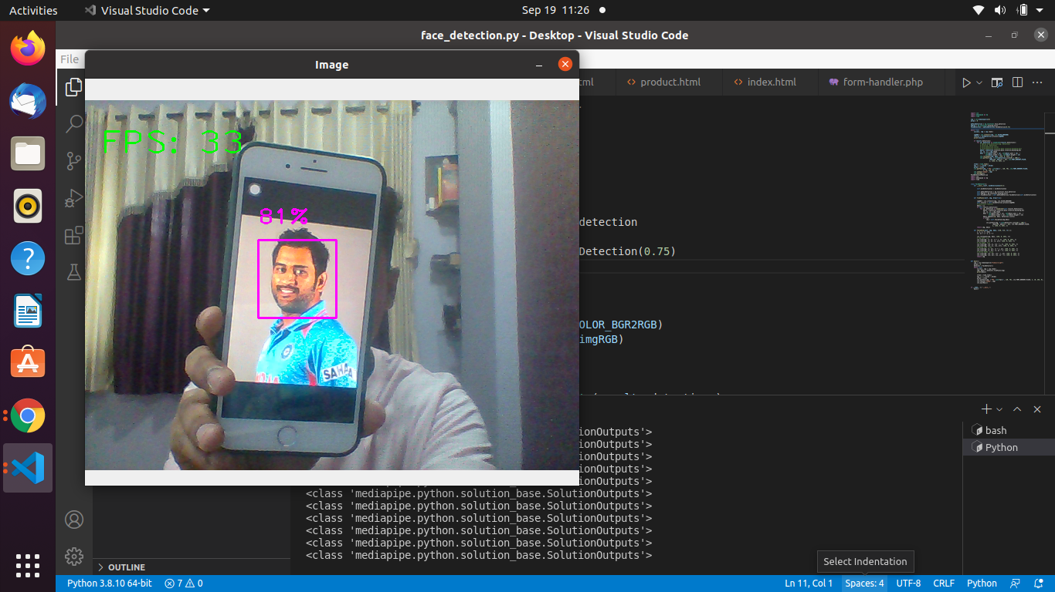

REAL-TIME FACE DETECTION

Real-time face detection involves detection of a face from a series of frames from a video-capturing device. While the hardware requirements for such a system are far more stringent, from a computer vision stand point, real-time face detection is actually a far simpler process thandetecting a face in a static image. This is because unlike most of our surrounding environment, people are continually moving. We walk around, blink, fidget, wave our hands
about, etc.
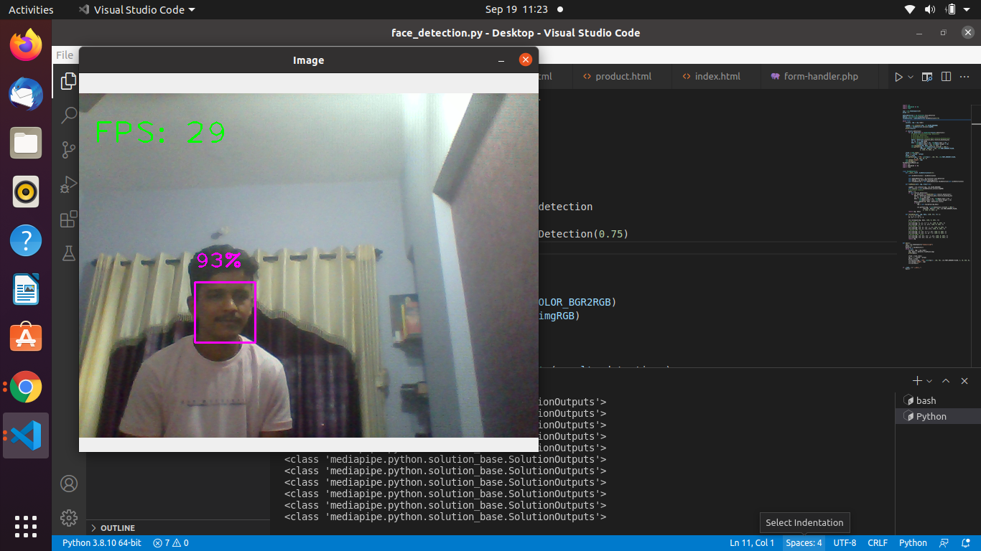

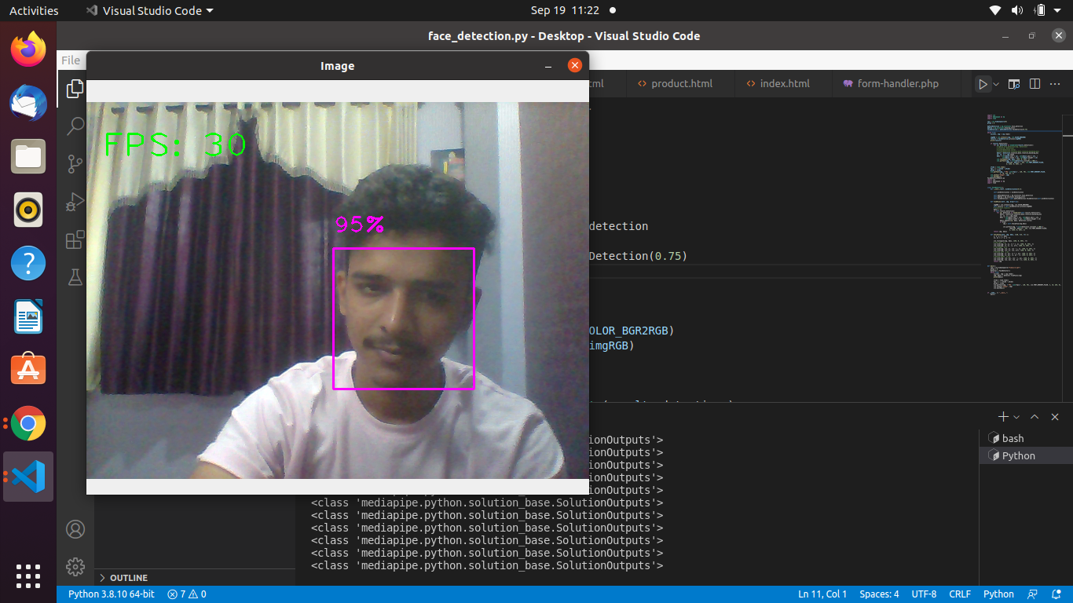

PROBLEM SCOP AND SYSTEM SPECIFICATION

The following problem scope for this project was arrived at after reviewing the literature on face detection

1 A system to detect frontal view faces in static images
2 A system to recognize a given frontal view face
3 Only expressionless, frontal view faces will be presented to the face detection&recognition
4 All implemented systems must display a high degree of lighting invariency.
5 All systems must posses near real-time performance.
6 Both fully automated and manual face detection must be supported
7 Frontal view face recognition will be realised using only a single known image
8 The frontal view face recognition system should be extended to a pose invariant face recognition
system.

CONCLUSION

The computational models, which were implemented in this project, were chosen after extensive research, and the successful testing results confirm that the choices made by the researcher were reliable.The system with manual face detection and automatic face recognition did not have a recognition accuracy over 90%, due to the limited number of eigenfaces that were used for the PCA transform. This system was tested under very robust conditions in this experimental study and it is envisaged that real-world performance will be far more accurate.The fully automated frontal view face detection system displayed virtually perfect accuracy and in the researcher's opinion further work need not be conducted in this area.
The automated vision systems implemented in this thesis did not even approach the performance, nor were they as robust as a human's innate face recognition system. However, they give an insight into what the future may hold in computer vision.

REFERANCE

• Adelson, E. H., and Bergen, J. R. (1986) The Extraction of Spatio-Temporal Energy in
• Human and Machine Vision, Proceedings of Workshop on Motion Representation and
• Analysis (pp. 151-155) Charleston, SC; May 7-9
• AAFPRS(1997). A newsletter from the American Academy of Facial Plastic and Reconstructive Surgery. Third Quarter 1997, Vol. 11, No. 3. Page 3.
•Baron, R. J. (1981). Mechanisms of human facial recognition. International Journal of Man
Machine Studies, 15:137-178
•Beymer, D. and Poggio, T. (1995) Face Recognition From One Example View, A.I. Memo No. 1536, C.B.C.L. Paper No. 121. MIT
• Brennan, S. E. (1982) The caricature generator. M.S. Thesis. MIT.
• Brunelli, R. and Poggio, T. (1993), Face Recognition: Features versus Templates. IEEETransactions on Pattern Analysis and Machine Intelligence, 15(10):1042-1052
• Craw, I., Ellis, H., and Lishman, J.R. (1987). Automatic extraction of face features. Pattern Recognition Letters, 5:183-187, February.
• Dunteman, G.H. (1989) Principal Component Analysis. Sage Publications.

